Green Society Public School
D- 24
Ratnanagar-7, Sauraha, Chitwan
Third Terminal Examination-2082
Class: Three Time: - 1 hr. F.M.: 25
Sub: Computer
Name: Roll No.: Sec.:
________________ ______________ OBT.MARKS:
INVIGILATOR EXAMINER
- Fill in the blanks. [4×1=4]
[Text, Automatic, Word Pad, Cursor]
  - Computer is ……………..
  - ……………. is the blinking line on the screen.
  - The ……………. tool is used to write text on the Paint screen.
  - …………….. allows you to create simple letters and documents.
2. Write True or False. [4×1=4]
- A device that prints text or illustrations on the paper.
- The round shaped button on the left of the taskbar is the start menu.
- Curve tool is used to draw curved shaped objects.
- Fonts refers to the way text is set with respect to the margins.
3. Match the following. [4×1=4]
- Word wrap used to erase a drawing
- Eraser tool Automatic placement of word in next line
- Data A work area in Windows
- Desk top The collection of raw-facts
4. Identify the pictures. [ 5×1=5 ]
a)
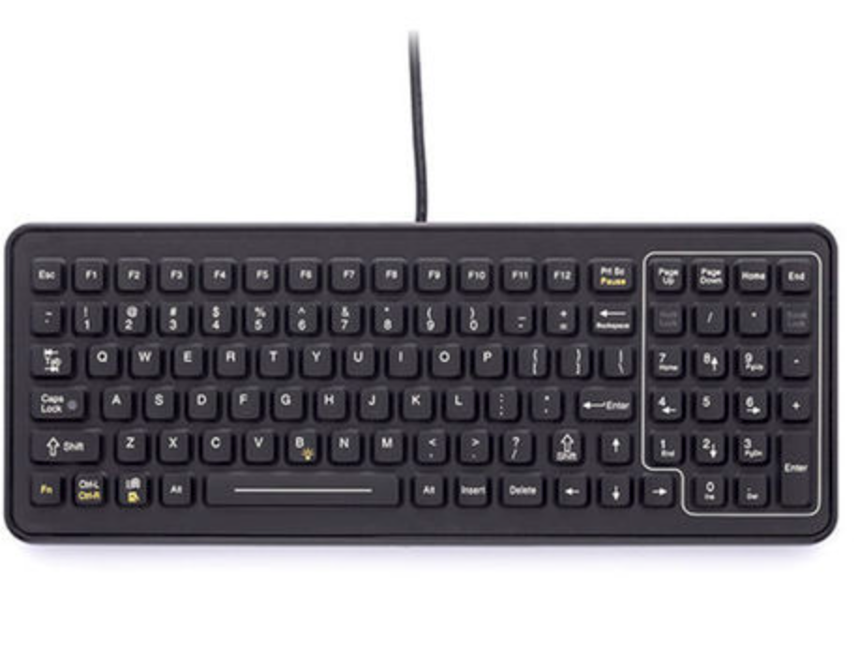
b)
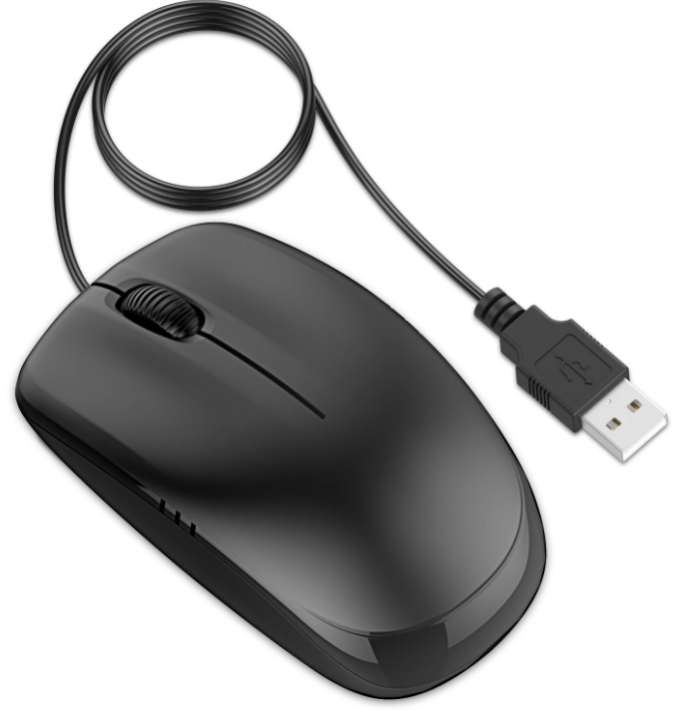
c)
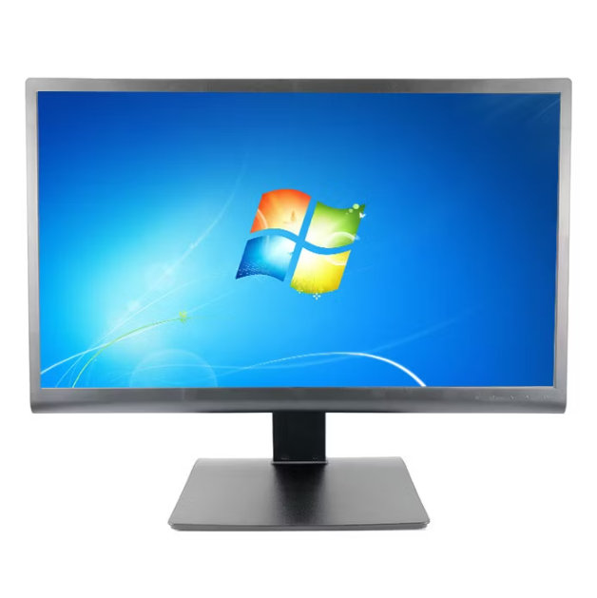
e)
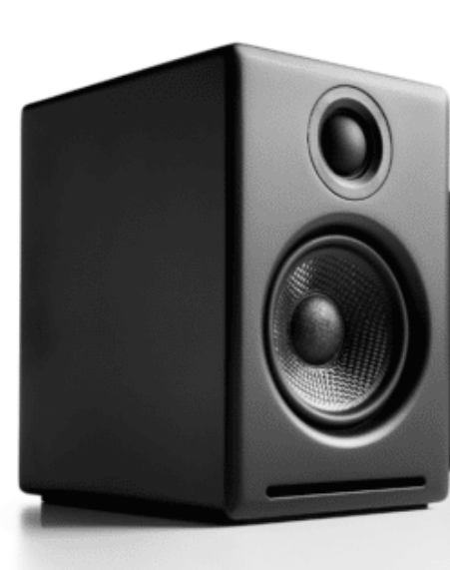
d)
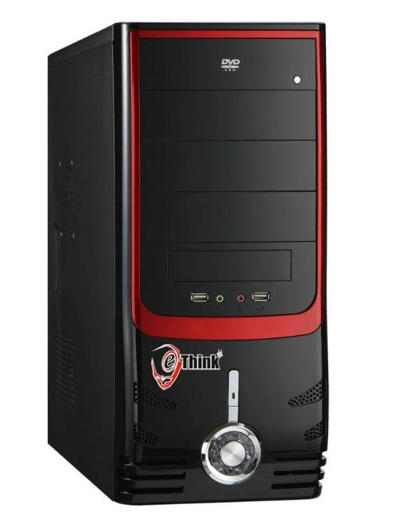

5. Answer the following questions. [4×2=8]
- Write any two features of computer.
…………………………………………………………………………………………………
…………………………………………………………………………………………………
…………………………………………………………………………………………………
- What is a Paint program?
:…………………………………………………………………………………………………
…………………………………………………………………………………………………
…………………………………………………………………………………………………
- Why do we use Zoom tool?
…………………………………………………………………………………………………
…………………………………………………………………………………………………
…………………………………………………………………………………………………
- What is a word wrap?
…………………………………………………………………………………………………
…………………………………………………………………………………………………
…………………………………………………………………………………………………
The End

